CPE301 – SPRING 2020

Design Assignment 2B

Student Name: Jason Villanueva

Student #: 2001255420

Student Email: [villaj21@unlv.nevada.edu](mailto:villaj21@unlv.nevada.edu)

Primary Github address: <https://github.com/jasonvillanuevagit>

Directory: <https://github.com/jasonvillanuevagit/submission_designAssignments-/tree/master/DesignAssignment2B>

1. **COMPONENTS LIST AND CONNECTION BLOCK DIAGRAM w/ PINS**

Atmel Studio 7.0 Atmega328PB-Xmini PC Multi-Function Shield Wire

- Assembler -LEDs

- Simulator

- Debugger

PINS & PORTS USED

1. **INITIAL/MODIFIED/DEVELOPED CODE OF TASK 1/A**

C-PROGRAMMING CODE

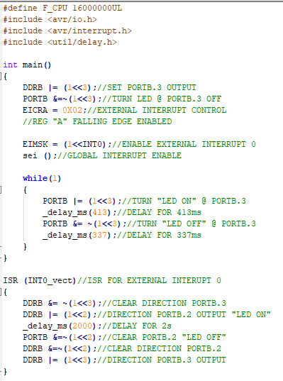

ASSEMBLY-PROGRAMMING CODE

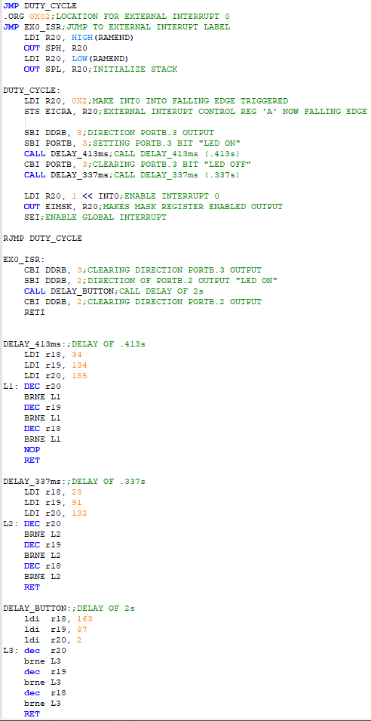

1. **DEVELOPED MODIFIED CODE OF TASK 2/A from TASK 1/A**

**N/A**

1. **SCHEMATICS**

1. **SCREENSHOTS OF EACH TASK OUTPUT (ATMEL STUDIO OUTPUT)**

N/A

1. **SCREENSHOT OF EACH DEMO (BOARD SETUP)**

1. **VIDEO LINKS OF EACH DEMO**

C program Video Demo

<https://youtu.be/AuZmo5hftx4>

Assembly Program Video Demo

<https://youtu.be/St9aSQlnG44>

1. **GITHUB LINK OF THIS DA**

<https://github.com/jasonvillanuevagit/submission_designAssignments-/tree/master/DesignAssignment2B>

**Student Academic Misconduct Policy**

<http://studentconduct.unlv.edu/misconduct/policy.html>

“This assignment submission is my own, original work”.

Jason Villanueva